
Silly Stuff on Ebay
Goofy Stuff for Sale


Table of Contents

Ebay—and you thought it was serious 3
Reflections on Reflective Surfaces 4
Broken Hearts = Brokered Deals 5
Toast Me Baby 7
You Know You Want It 8
These Hands Were Made for eBay 9
Conclusion 10

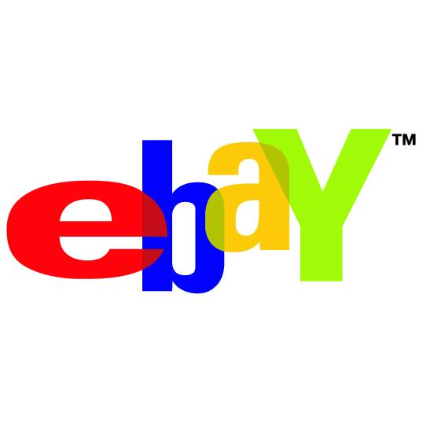
You Thought eBay was Serious
And for the most part, it’s very serious. Buying, selling, making money on all kinds of things; it’s big business.
You know eBay. It’s huge and growing bigger every year. It’s become the world’s biggest garage sale, fire sale, going-out-of-business sale and every other kind of sale you can think of.
People sell things they don’t need any more, they sell things they’ve created, they sell mundane items and things that would make your mama blush.
If you’ve ever spent time perusing the thousands of ads on eBay, then you may have come across a few things that were odd, strange or downright bizarre.
You’re not alone. Even Jay Leno from The Tonight Show on NBC has a regular piece about the crazy things put up for sale on eBay. Mr. Leno offers up an item and asks the audience to say if they think it’s sold on eBay or not. There are some very crazy things going on in the world of eBay.

Reflections on Reflective Surfaces
You may have heard (and if you were very unlucky, seen) the story about a gentleman who had a lovely silver tea kettle he wanted to sell on eBay.
Most sellers know that in order to make sale they need to post a picture of their item. It should be an exceptional picture and one that stands out from all the other items for sale.
This particular gentleman went above and beyond the call of duty in photographing his item.
We don’t know if it was a hot day when the picture was taken, but what we do know is that the seller was engaging in photography while wearing only his birthday suit.
The reason we know this is not because he told anyone but because he seemed to have forgotten that a silver tea kettle is a reflective surface and posted the picture he’d taken with his nude body gracing the front of the kettle.
I’m not going to give you the picture here because it’s disturbing on many levels. Suffice it to say that it’s still available to view online if you’re of a mind to Google such things as ‘naked man reflected on eBay’, but we wouldn’t recommend it unless you have a strong stomach.

Broken Hearts = Brokered Deals

Once upon a time there was a man and a woman who fell madly in love. They loved each other so much that they decided to seal their love by entering into the holy bonds of matrimony. For a while all was bliss, sunshine, roses and fluffy kittens. Life was good.
Then one day the man came home early from work to surprise her and ended up surprising himself instead. He discovered that the love of his life was cheating on him with his best friend.
How to handle this situation? Sell all her stuff on eBay of course! And if that’s not enough revenge, remember those pictures you took of her on your honeymoon? Yep, toss those into the sale batch as well. How about the video of her cheating on you with her married boyfriend? Why not?
Some people have actually posted auctions to sell the cheating spouse. We’re fairly certain that the sale of humans, cheating or otherwise, is illegal.
EBay will pull any ad that violates their terms of service, but sometimes the auctions are left up long enough for the ad to become infamous.
So remember, if you’re going to do something naughty like cheating on a spouse or a significant other, you may not only lose your stuff but you could be put up for sale.

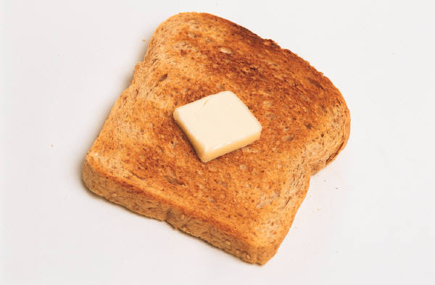
Toast Me Baby
You get up in the morning and pop some bread into the toaster for breakfast. Watch out! You might not end up with toast but with EBay Toast!
This is where you’re going along with your normal morning routine and suddenly the likeness of Abraham Lincoln appears on your toast!
You have two options: chew up old Abe and go on about your business, or put it up for auction on eBay.
Will people bid on such a thing? Oh goodness, you vastly underestimate people’s desire for the bizarre if you think something like that won’t garner dozens of bids!
People have purchased the likeness of the Virgin Mary on a toasted cheese sandwich, and even the likeness of the famed creator of the Daleks on toasted bread.
If toast isn’t your thing, then perhaps you might consider buying a possessed pancake from a family in Germany who are selling it in order to free themselves from the evil it has brought to their family. Strange things began happening in their home after the pancake was created during a loss of electricity.
And if you’re wondering—yes, the pancake was sold at auction. We don’t yet know if the demon took up residence with the new pancake owner.

You Know You Want It
If a famous person has owned—say a ball gown, or a piece of jewelry—the value of the item if sold is much higher than it would otherwise be.
Now imagine if you will, a ball point pen that was actually stolen from Satan himself!
Who wouldn’t want to own a something held in the long pointy fingers of the dark prince himself right after he signed a deal with someone for their very soul?
Satan's pen can be found here if you’re interested.
Personally, I’d be afraid it would scorch my fingers.

These Hands Were Made for eBay
Someone in Pennsylvania has put up something for auction that is beyond odd. It borders on the pathetic with a slight hint of someone needing attention. Here’s the auction, in the owners (can you own a slap?) own words.
Up for bid is a hard hand smack to the face by my lovely wife! This is a 1 time smack only! You MUST travel to the location of what is chosen! You MUST be fully clothed with nothing covering your face! This will be a hard slap and you will be signing a waver so that no lawsuit happens due to any injury/injuries that may occur! I, (Her Husband), will be there to protect her! NO TYPE OF RECORDING WILL BE USED! After bid is final, the arrangment will be made! This is for both women and men! Can you take a hard slap to the face by my lovely wife?

If I were you I’d avoid this auction—you can probably find someone that lives a lot closer to you to give you a slap for free. No, really.
Conclusion
When they say you can find anything on eBay—they’re not kidding. From toast with faces of famous dead people to people selling pens stolen from the devil. If you want it, it might be there for the taking.
Ebay is the world’s biggest garage sale and one person’s junk is another person’s treasure.

